**Admin Screen:**

We can configure chat instructions, user reply mapping, api endpoint configuration, default values configuration for target environment and salesforce in the admin app.

**Chat Instruction setting**

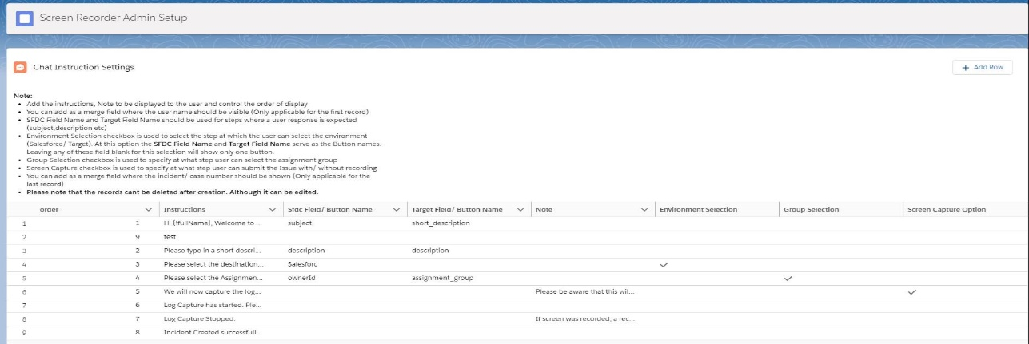

* Add the instructions, Note to be displayed to the user and control the order of display
* You can add as a merge field where the user full name should be visible (Only applicable for the first record)
* **SFDC Field Name** and **Target Field Name** should be used for steps where a user response is expected (subject,description etc)
* Environment Selection checkbox is used to select the step at which the user can select the environment (Salesforce/ Target). At this option the **SFDC Field Name** and **Target Field Name** serve as the Button names. Leaving any of these field blank for this selection will show only one button.
* Group Selection checkbox is used to specify at what step user can select the assignment group
* Screen Capture checkbox is used to specify at what step user can submit the Issue with/ without recording
* You can add as a merge field where the incident/ case number should be shown (Only applicable for the last record)
* **Please note that the records can’t be deleted after creation. Although it can be edited.**

**API and storage settings (Screen Recorder Settings Custom Setting Object)**

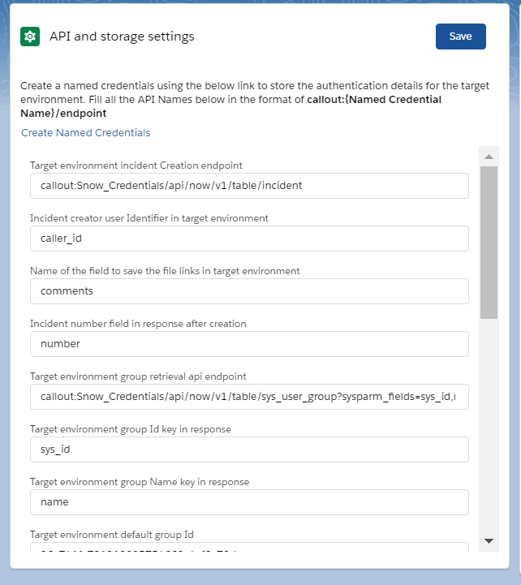

1. For all endpoints the API endpoints are to be added in the format of **callout:{Named Credential Name}/endpoint**
2. For the endpoint which is used to get the group names from target environment, we need to use the {!userId} merge field in the url to replace the user identifier from Salesforce user which has been mapped to the target environment. (Usually the federation Id)
3. The descriptions of each field and what it is used for is mentioned in the field labels.

**Default Target and Salesforce Environment Values**

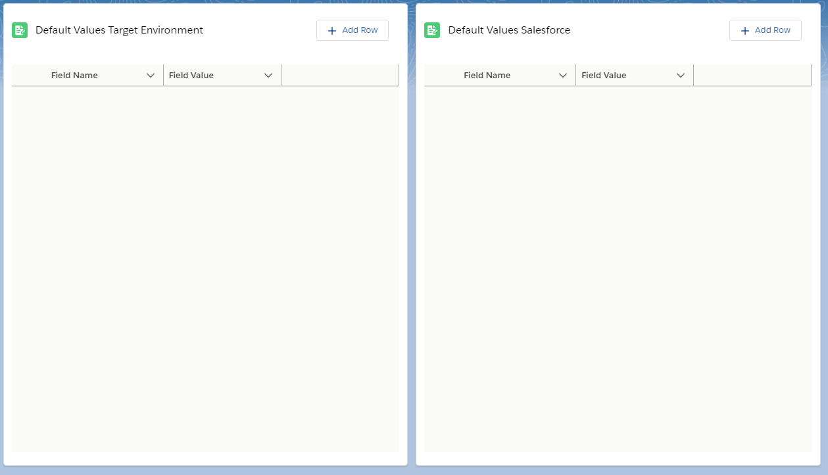

1. This is used to add the default values for case/ Incident creation (Type, configuration Item etc). To be entered as fieldname, FieldValue pair. Record deletion is allowed.

**Post Installation steps:**

1. Use the admin screen to configure the chat instructions, api endpoints and other settings.
2. Create a connected app in the org with oauth enabled.

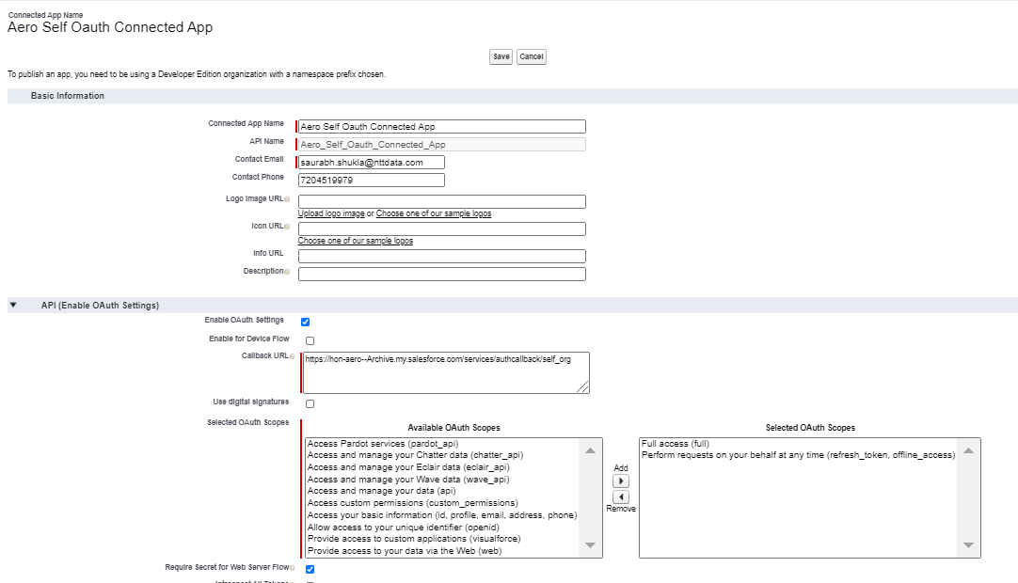

1. Create an auth provider in the same org with the client id and client secret of the same org. Make sure you add the same scopes in the connected app, auth provider and named credentials.

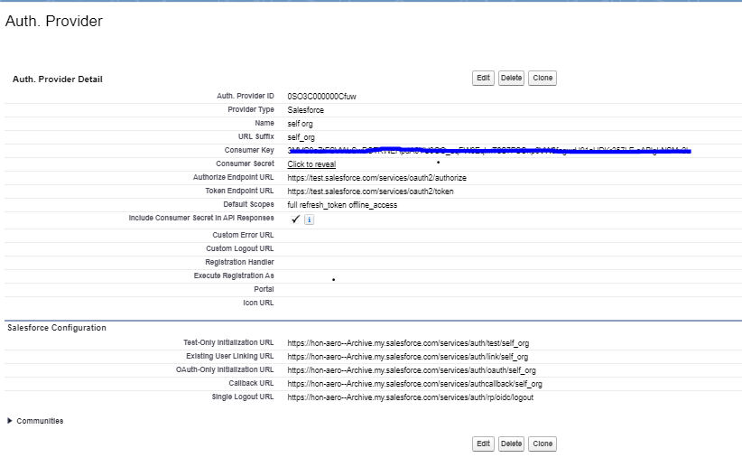

1. Copy the login url from the auth provider related list and use it in the connected app callback url.

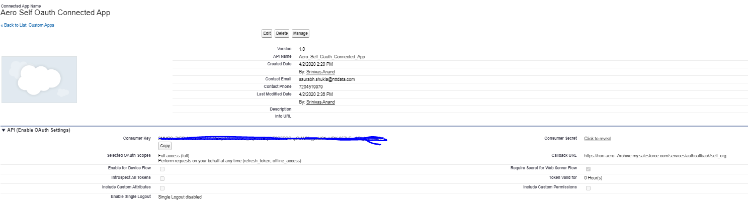

1. Create a named credential named ‘self_org’ and use the Named principal authentication and oauth 2.0 option.
2. Lookup the auth provider that was created and use the same in the named credential.
3. Allow merge fields in the Http header, generate authorization header, start authentication flow on save should be checked. 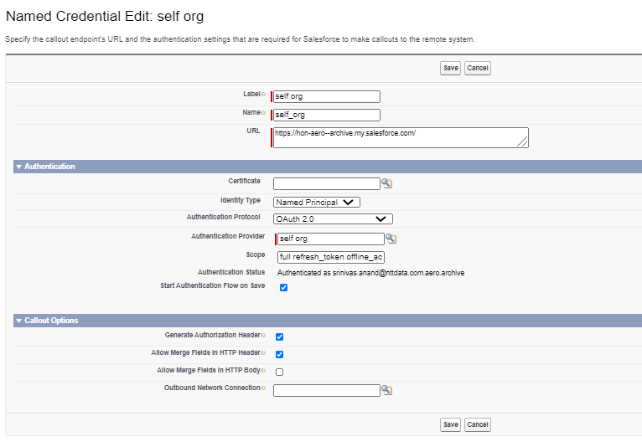
4. Authorize the named credential on save.

**Named Credentials:**

Create a named credential of your choice of authentication to connect to the target environment where the incidents need to be created.

Below screenshot shows the named credentials created for SNOW integration with username password authentication.

While specifying endpoints in the Admin tool or custom settings, ensure you type the endpoints in the below format:

*callout:{Named Credential Name}/endpoint*

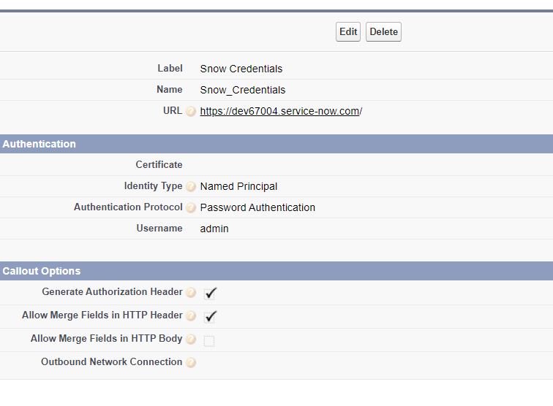

**Classic version custom setting names:**

Go to ‘screen recorder settings’ custom setting and create records with below Names and fill the desired values in the field_value__c field.

[API_Caller_Id_Field](https://hon-aero--archive.my.salesforce.com/aIL3C0000008OVw?setupid=CustomSettings) – Incident creator user Identifier in target environment

[API_creation_endpoint](https://hon-aero--archive.my.salesforce.com/aIL3C0000008OW9?setupid=CustomSettings) - Target environment incident Creation endpoint

[API_incidentNumber](https://hon-aero--archive.my.salesforce.com/aIL3C0000008OW6?setupid=CustomSettings) – incident number identifier from the json response for incident creation

[debugLevelId](https://hon-aero--archive.my.salesforce.com/aIL3C0000008OW4?setupid=CustomSettings)- default debug level Id for capturing logs

[file_deletion_Interval](https://hon-aero--archive.my.salesforce.com/aIL3C0000008OWB?setupid=CustomSettings) – log and recorded video file deletion interval

[FLDVF_description_field](https://hon-aero--archive.my.salesforce.com/aIL3C0000008Ob5?setupid=CustomSettings) – Description field on the incident for target environment

[FLDVF_subject_field](https://hon-aero--archive.my.salesforce.com/aIL3C0000008ObA?setupid=CustomSettings) – subject field on the incident for target environment

[libraryName](https://hon-aero--archive.my.salesforce.com/aIL3C0000008OVy?setupid=CustomSettings) – Library api name where the recordings and files need to be stored

[recorded_video_alert_note](https://hon-aero--archive.my.salesforce.com/aIL3C0000008OWA?setupid=CustomSettings) – alert note to be added in the description field of the incident regarding the file deletion interval

[targetEnvUserMappingField](https://hon-aero--archive.my.salesforce.com/aIL3C0000008OWD?setupid=CustomSettings) – user mapping field name which will be used to map the user record from salesforce to target environment (usually federationidentifier/ employee id)

**Default values for incident creation:**

For Default fields to be added use the same custom setting object and create fields in the below format.

‘API_’ + field name where default values need to be added.

Add the default values in the field_value__c in the custom setting record. Check the isAPI__c checkbox to true.

**Instructions:**

Go to ‘Customer Support Instructions’ custom metadata and create a record with the DeveloperName=’Instructions’.

Fill the Instructions in the Instructions__c custom field in separate lines. This will be shown as bullet points in the page.

Fill the Note field if required which will be displayed in bold after the instructions.

**Batch scheduling:**

To clear the recorded video files and logs from documents fill in the deletion interval from the admin page or create a record with Name file_deletion_interval in ‘screen recorder settings’ custom settings and fill in the number of days for which the records are deleted.

Ex: field_value=14 will delete the files which were created 2 weeks ago and if the job is scheduled to run everyday then it will delete the files everyday that were created 2 weeks ago from that date.

Batch class name: clearRecorderDataBatch

Can be scheduled from apex scheduling window.

**Permission Sets:**

Screen recorder Admin Permission – Assigned to the admin to use the ‘Screen Recorder Admin’ Application and the screen Recorder application.

Screen recorder User Permission – Assigned to the any user who uses the screen Recorder application.

**Library (Content Workspace):**

Create a library to store the files related to the application (logs and recordings) and give Author permissions to all internal users and ‘Workspace administrator’ Permissions to all admins.